McKinney Block of the Month: March

When we think of March, we think of St. Patrick’s Day and the shamrock. The three-leaf clover, a type of trefoil plant, has been considered the unofficial national flower of Ireland for centuries. Irish legend says that Saint Patrick used the shamrock as an educational symbol to explain the Holy Trinity to nonbelievers as he converted the Irish to Christianity in the fourth century.
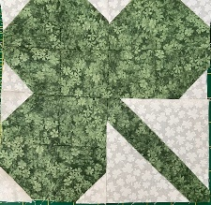  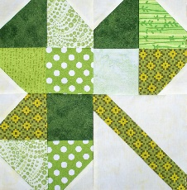 | To complete this block:  You need a background fabric and fabric for the clover  Cut twelve 2-1/2” green (clover) squares  Snowball* one corner on 9 of the clover squares  Cut one 5” square background fabric  Cut the 5” square diagonally (corner to corner)  Cut a green strip 1-1/2” x 7”  Sew the strip along the diagonal cut of the background square. This will be the stem of the clover  Trim the “stem” block to 4-1/2” square with the stem centered  Lay out the finished squares to form clover as shown and sew

*How to snowball a corner: lay a 1-1/2" background square atop one corner of a 2-1/2” square, right sides together and edges aligned. On the back of the small square, lightly draw a diagonal in the direction shown at the right. Sew on this marked line. Cut off the excess seam allowance and press the remainder towards the outside. | 